Website Design Report

Name: Vic, Hong

Student ID: 47523483



Overview

* Introduction
* Site Map
* Low fidelity
* High Fidelity
* Design decisions I plan to make based on Nielsen’s usability heuristics.
* Conclusion
* References list

Introduction

This website would introduce some common Taiwanese cuisine, including its history and making process. Additionally, since I constructed a shopping-cart program in my first Python assignment, if it is possible, the program of shopping-cart would be developed into the website as well, allowing website users who want to attempt Taiwanese cuisine a convenient way to purchase their ingredients in supermarket.

This program offers several functions that is useful for shopping, you could choose a cuisine, and add its ingredients into the shopping cart.

Taiwanese cuisine, or its native nickname “Taiwan Xiao-Chi”, is considered as one of the special regional foods in Asia. Due to the colonization by both China and Japan, Taiwan Xiao-Chi have been deeply influenced by these two countries. For example, a story said that Taiwanese rice ball, which is known as “Png Wan”, was invented because in the period of Japanese colonization, general Taiwanese public cannot afford Sushi, food vendors then announced a rice ball to satisfy the desire of eating Sushi from Taiwanese. This rice ball has a similar outline than Sushi, however, usually it contains egg, pork, pickled vegetable instead of expensive and fresh ingredients such that fish or shrimp. People then name this rice ball in Taiwanese“Png Wan”, which means a circle rice ball and wraps all of the ingredients inside of it.

Although Australian or western food is delicious and fresh for me, I sometimes would still miss my hometown cuisine hardly. As a result, I chose Taiwanese Xiao-Chi as my topic of the website to fix my hometown-food sick, and also, make those who are interested in Asian, or Taiwanese food to know this kind of simple but happiness home style cuisine.

Site Map

The website could be departed into three parts, which are 1, 2, and 3. Part 1 is Home Page, it is the center of the website and users can access part 2 via home page. Part 2 is classified as four topics and three of them would relate to Taiwanese Xiao-Chi and the remaining one is shopping list. Each of the Taiwanese Xiao-Chi is clarified into part 2 topics, users can access them by clicking further link in part 2 pages.

Low fidelity

Home page and Part 2 page handwriting sketches:

The sketch displayed at left side is the landing page of my website, at the very top of the page is written “Taiwan Xiao-Chi”, which will be deployed at every page in my website. Users could click it and return to home page at any time and in any situation.

Following by the icon, a bar-shape menu would be added into the page, it gives users directions about how to use the website. The website is about Taiwanese Xiao-Chi and commonly Taiwanese Xiao-Chi is considered that have 2 diversities, which is Northern and Southern of Taiwanese Xiao-Chi. Therefore, my website would follow this rule to introduce them respectively. In addition, despite Taiwan is not such a huge island (a little less than Netherlands), there is a huge difference between Northern and Southern Taiwanese Xiao-Chi, a page would be developed to give the explanation and examples of it.

The last topic in menu is shopping list, it would list the ingredients of the Xiao-Chi as long as the user click “Add it to shopping list!” button at the end of the cuisine introduction page (which is part 3).

In the main area of home page, a Taiwan map would be printed at the right side of it, if it is possible, I would try to make it funnier and more interactive. In terms of the left side, a brief illustration and idea of my website and instructions of how to use it would be given as well.

Part 2 (shopping list page) and Part 3 Page handwriting sketched:

Shopping list page gives a storage place for users to record what cuisine they like while using it. The list would be displayed at the main area of shopping list page. It includes the ingredients name, measure, and amount. If it is possible, I would order ingredients name alphabetically and also comment from what cuisine is these ingredients had been added.

Part 3 is the most important part of my website, it would record the description of the cuisine, making process and some pictures of it.

Since not all of the Taiwanese Xiao-Chi are suitable to make at home, for example “Kong Oan” is not a simple cuisine for public to make at their kitchen because they usually need several complicated processes to make it preserve for a long time. A comment or explanation of why the cuisine is or is not suitable to make by ourselves we be given when users’ mouses touch the “Yes” or “No” of the answer.

The last part of part 3, “Add it to shopping list!” would command the website to put cuisine that users is now browsing into shopping list so that users could know what they should purchase when they are in a supermarket, just like another shopping list application works.

High fidelity

The following below is high fidelity of my website, its online link could be access online: <https://miro.com/app/board/uXjVMSdJuDE=/>.

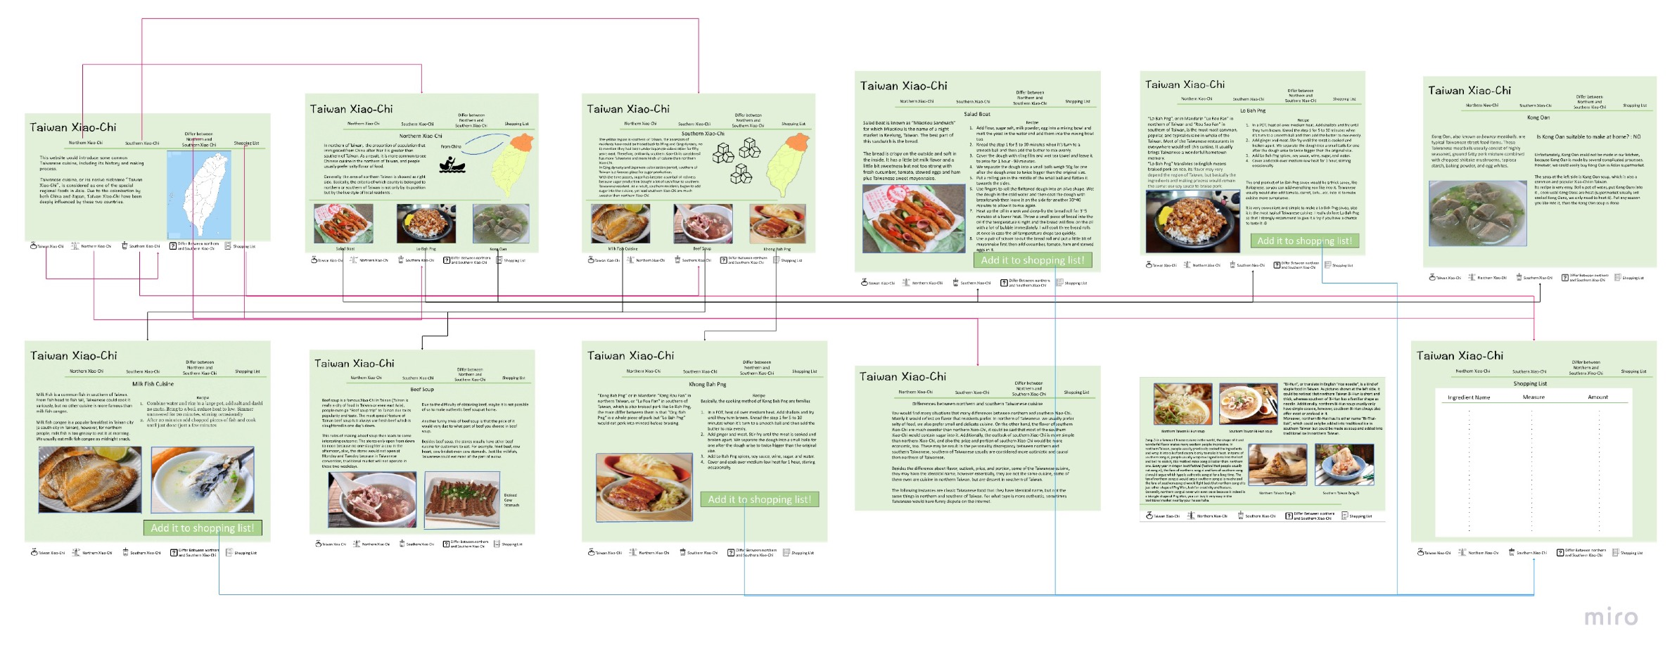

Design decisions based on Nielsen’s usability heuristics.

Basically, my website would follow Nielsen’s 10 Usability Heuristics (Nielsen, 1994). In the following part of the report, I would propose the sections of my website that use Nielsen’s 10 Usability Heuristics.

1. Visibility of system status: To reflect the Visibility of system status, I would develop a command for every button in my website if they are touched by users’ mouse, it would slightly change the color or become bigger to imply users that this is the button you are touching.

On the other hand, 4 of the Xiao-Chi included in my website is suitable to make at home, so “Add it into shopping list” is available in such these Xiao-Chi. To present Visibility of system status, if users finish adding a Xiao-Chi into a shopping list, a little window would bounce out and show the users that the command is done.

1. User control and freedom: Combine the exit function into the menu at the top and bottom of every page, the websites would give users an obvious way to go everywhere they want to go. It is easy for users to return to the home page whatever the page they are searching.
2. Consistency and standards: The menu would always at the top and bottom of the page, also, the “Taiwan Xiao-Chi” button, which would lead users back to the home page, is consistently deployed at the left top in every page. User would not have to spend extra time to find out where the certain button is it.
3. Recognition rather than recall: For most of the foreigners, it is difficult for them to remember the outfit of northern and southern Taiwan, but most of them may know Taipei 101 is in the northern of Taiwan and bubble milk was invented in southern of Taiwan. Therefore, I put Taipei 101 and bubble tea icon in front of the button “northern Taiwan” and “southern Taiwan” instead of their outfit.
4. Aesthetic and minimalist design

The food website aims to offer some brief and simple information to those who are interested in but not for a place to show off the design of the website. As a result, I would not use much programming to make website luxury but would still maintain a great design.

Conclusion

To sum up, this website is to give someone who is interested in Taiwan Xiao-Chi a way to have the very basic recognition from a native Taiwanese(me). Even though I do not introduce for much cuisine of Xiao-Chi, I choose the most famous group of it. Hoping the website will bring some benefits to those who enter it when it is done. I tried to make design decisions that include all of the Nielsen’s 10 Usability Heuristics, however, figuring out the idea base on certain heuristics of Nielsen’s 10 Usability Heuristics would not be an easy task. Also, although I learned plenty of programming that could be use in constructing a website, however, in reality it is much more difficult to deploy them. I think I will spend more time diving into other websites that I think it would profit my final implementation or ask my friends about the knowledge related to it. Hope I can have a great work finally!

References List

Nielsen, J. (1994, April). *10 Usability Heuristics for User Interface Design* Retrieved from

<https://www.nngroup.com/articles/ten-usability-heuristics/>.